**Document for ShopBridge application:**

The ShopBridge application was created using c# ASP .Net MVC along with Web API and Entity Framework (Object Relational Mapping).

This app can perform all the below operations as required.

* Add a new item to the inventory
* Modify an item in the inventory.
* Delete an item from the inventory.
* Lists the items in the inventory.

SQL Server is used for the data storage needs.

Alertifyjs is used for making alerts for all the operations.

**Please find the screenshots of the application added below:**

1. Listing the items in the inventory:

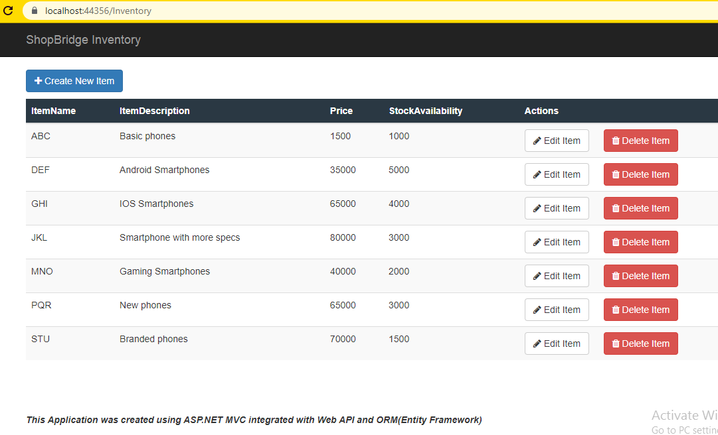

2. Page to add a new item to the inventory:

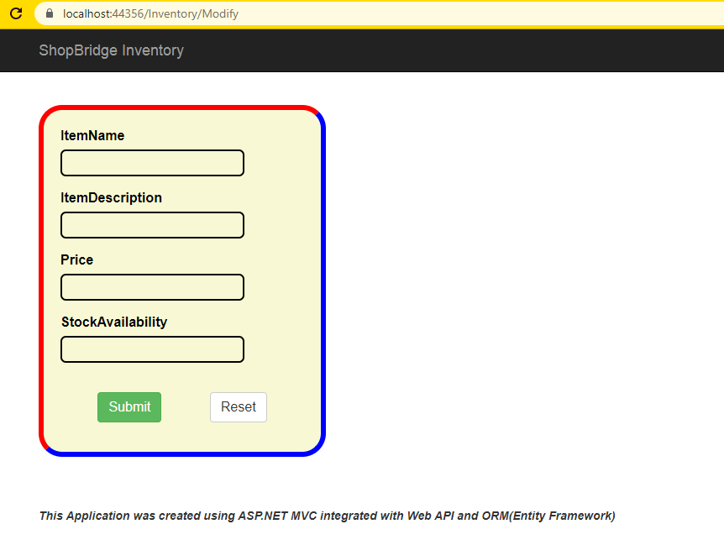

3. Modify an item in the inventory using Edit Item button in home page.

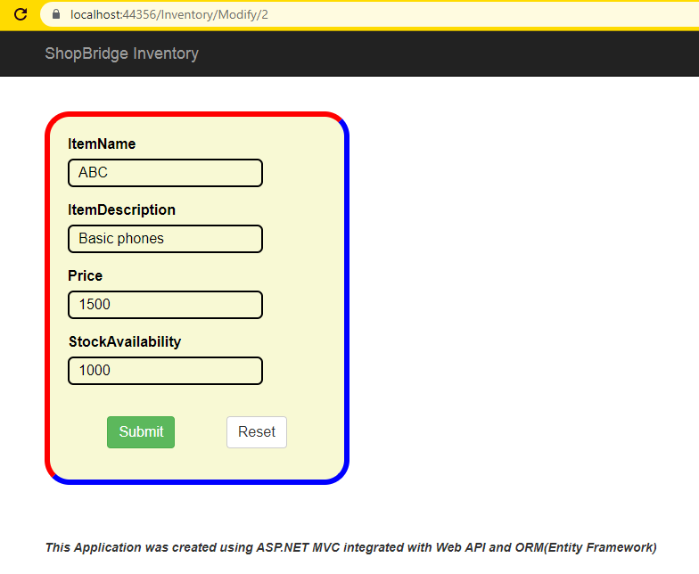

4. Delete item from the inventory and confirmation alert for deleting:

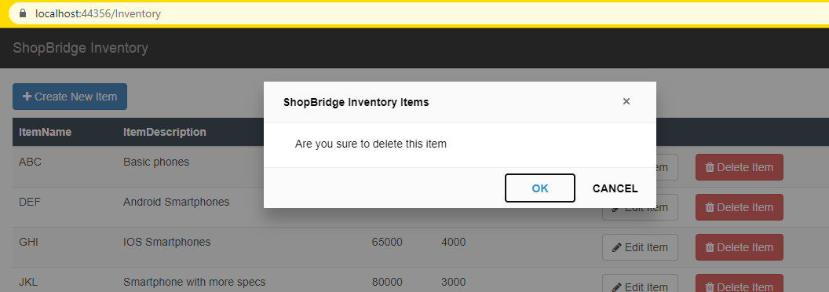

Screenshot with item deleted msg.

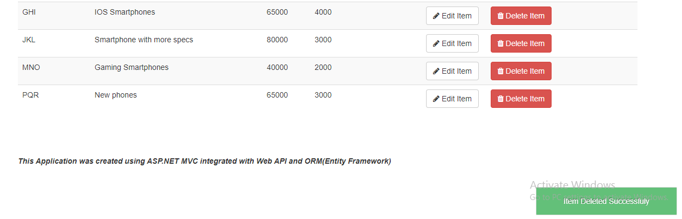

Validations done on each fields.

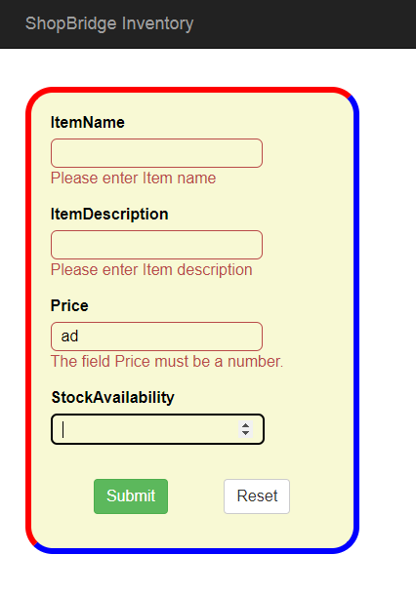

**Tracking:**

1. Data store design – 1Hr 40Min

2. API and service logic – 1Hr 20Min

3. Unit Test Coverage – 30Min